Marketing Competitive Analysis

[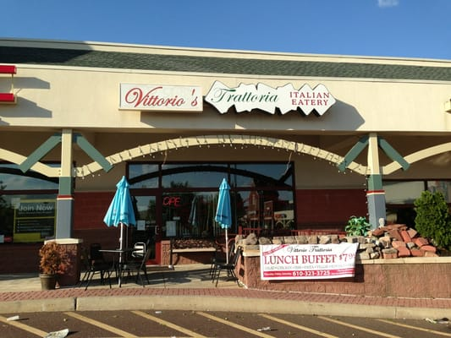](https://www.google.com/url?sa=i&rct=j&q=&esrc=s&source=imgres&cd=&cad=rja&uact=8&ved=2ahUKEwjClvvo9IrlAhUKHDQIHeYBBiAQjRx6BAgBEAQ&url=https%3A%2F%2Fwww.yelp.com%2Fbiz%2Ftrattoria-vittorio-pottsown-pottstown&psig=AOvVaw22a4pv3W9gI9wXZtPn6T81&ust=1570563959541542)Vittorio’s



The San Diego Location

Business Information

* + - Vittorio’s (Vittorio’s Family Style Trattoria)
    - Located Off of Highlands Village Drive from Camino Del Sur in the shopping mall
    - Hours are 11:00AM-9PM Monday-Friday, 3:30-9PM Saturday & Sunday
    - Italian family sit-down restaurant
    - Chain restaurant, has locations all across the map
  + This business is in a strategic location although being somewhat near other competitors in similar businesses, and despite being tucked to the side of the shopping center, it is near multiple residential areas, is near schools (it is a family restaurant), and easily accessible via Ted Williams Freeway. It also has an advantage in advertising, because it is one of the oldest buildings there, its sign is near the top of any local advertisement. It also recently adopted a meal delivery service, which makes being near a highway an even greater advantage.
* As I have said before, Vittorio’s is an Italian sit-down family restaurant at the side of a local shopping mall. Despite being a family diner, it also invites a certain elegance, because it also has a bar and meeting rooms. This means that not only are families with kids invited to encouraged to come, but also wealthier patrons coming as office workers, friends, or family reunions. The food is mildly expensive, but not too bad considering the quality of their

products.

Customer Information

* The business targets young American or Northern European parents in their 20s-40s, especially couples with kids. Recently they have been trying to expand their age demographic.